Aquatic Warbler Conservation Team

Hungary Field Trip 2004

15th to 20th of May

"DNA and Feather Sampling of the Hungarian Aquatic Warbler Population"

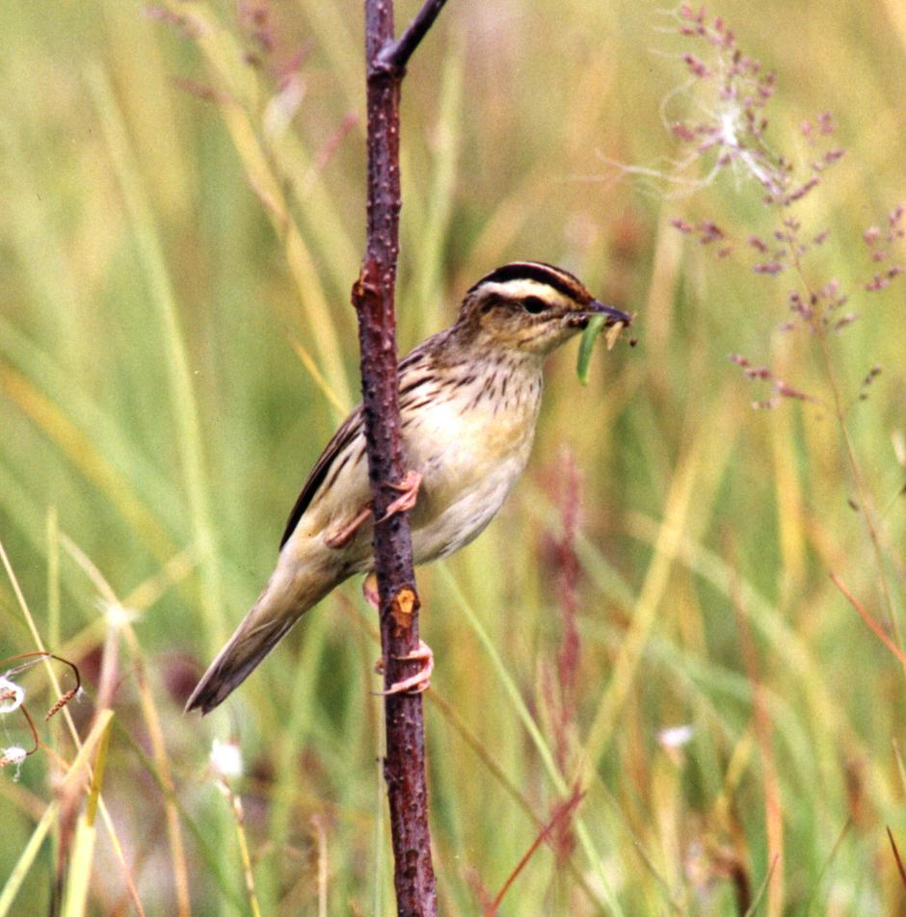
Photo: Alexander Kozulin

Final Report

written by Martin Flade, chairman
Aquatic Warbler Conservation Team

Hungary Field Trip 2004
"DNA and Feather Sampling of the Hungarian Aquatic Warbler Population"

Objectives of the project:

- To study the Aquatic Warbler habitats in Hungary;
- To take samples of >= 10 adult Aquatic Warblers for DNA and stable isotope studies;
- To exchange experience among the international Aquatic Warbler experts.

Participants:

- Victor Fenchuk | Belarus
- Alexander Kozulin | Belarus
- Arcady Skuratovich | Belarus
- Benedikt Giessing | Germany
- Katrin Giessing | Germany
- Martin Flade | Germany
- Karl Schulze-Hagen | Germany
- Antonia Schulze-Hagen | Germany
- Heinz Wawrzyniak | Germany
- Zsolt Végváry | Hungary
- Oskars Keiss | Latvia
- Zydrunas Preiksa | Lithuania
- Grzegorz Kiljan | Poland
- Jarek Krogulec | Poland
- Janusz Kloskowski | Poland
- Fernando Jubete Tazo | Spain
- Anatoly Poluda | Ukraine

Schedule of the field trip

Date | Activities
15th May 2004 | - Arrival at Hortobágy village  - Evening visit at the AW site Borsós SE of Hortobágy (place 1a, easternmost place); catching and feather sampling of 4 AW;
16th May 2004 | - Catching of AW at Borsós, place 1b; catching and feather sampling of 5 AW; habitat and vegetation description
17th May 2004 | - Working session (discussion group)  - Catching of AW at Borsós, place 1b; catching and feather sampling of 2 more AW; habitat and vegetation description
18th May 2004 | - Bird watching at different sites within the Hortobágy NP  - Evening visit of AW habitats in the SW-part of the NP (SE Nagyvan)
19th May 2004 | - Discussions, conclusions  - Bird watching  - Visit of the AW core breeding area near Nagyvan with Gábor Kovács
20th May 2004 | - Birding at the Hortobágy fish ponds;  - departure

Summary

The targets of the AWCT Field Meeting 2004 in Hungary were to study and discuss the Aquatic Warbler habitats in Hungary, to take samples of at least 10 adult Aquatic Warblers for DNA and stable isotope studies and to exchange experience among the international Aquatic Warbler experts. This targets have been fully met. Fifteen AWCT members, two (self-paying) guests and three National Park rangers participated in the field meeting. The Aquatic Warbler breeding habitats in the Hortobágy National Park near Hortobágy village (Borsós) and near Nagyvan have been visited, and habitat descriptions and vegetation analyses were prepared. 12 adult Aquatic Warblers have been caught (11 males, 1 female) and samples for stable isotope and DNA analyses have been taken. During an extended discussion session on the 17th May, current topics of Aquatic Warbler research and conservation have been discussed, including the current situation of the AW in Pomerania, the peculiarities of the Hungarian habitats, the drafted Ukrainian flyway project, new research results from Belarus and AW on migration and in Africa. The special features of the Hungarian AW habitats brought us to the conclusion, that it would be worthwhile to check similar habitats in Ukraine as soon as possible. This was realised immediately after the Hungary meeting by Anatoly Poluda and Dmitri Dubovik in June 2004 (see separate report). This additional expedition was financed with 700 € of saved money from the same small grant agreement (after having this agreed with Lars Lachmann, RSPB). – The feather samples have been submitted to Debbie Pain, RSPB (receipt confirmed). The DNA samples were kept by Benedikt Giessing to be analysed in the laboratories of Heidelberg University.

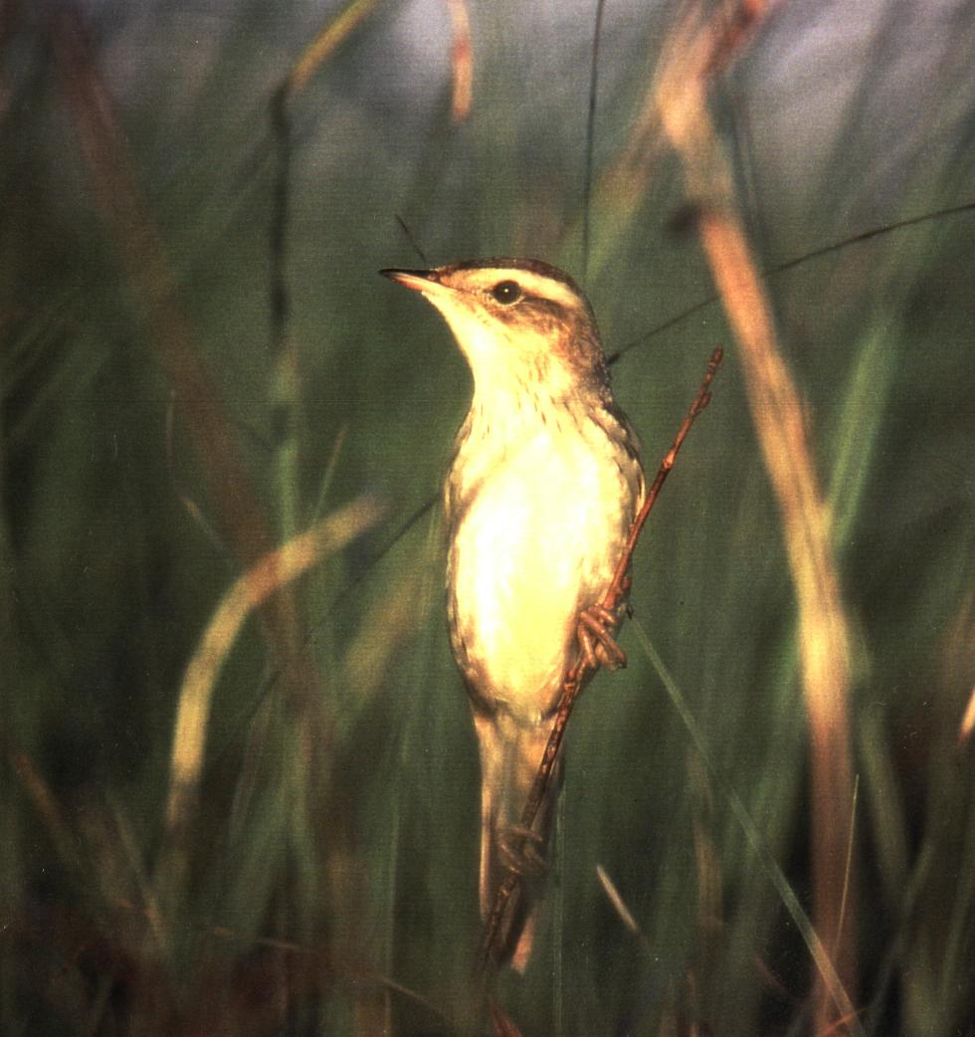

Photo: Franziska Tanneberger

Objectives and background

From 15th to 20th of May 2004 the AWCT held its annual field meeting in Hungary. The meeting was targeting to study the AW habitats in the Hortobágy Puszta. Most important task was to collect samples for DNA and stable isotope analyses.

As explained in the Aquatic Warbler Conservation Action Plan (p. 5), the background is as follows: "Recent studies on genetics and on stable isotopes in Aquatic Warbler feathers show that the German/north-west Polish population is genetically separate from all other studied populations (Giessing 2002), and that it has most probably a different, very restricted and more northerly wintering area than the other central and east European populations (Pain et al. 2004). This sub-population is sharply declining, and is thought to be the last remnant of the formerly huge north German population. The west Siberian population is geographically completely separate, is most likely genetically separate too, and is probably headed for extinction. In respect of these two sub-populations therefore it is likely that there will be a partial extinction of genetic variability within the species." - By means of the DNA finger prints it is also possible to assign birds on migration, e.g., caught for ringing in Belgium, France or Spain, to specific breeding sites.

- Since we had the opportunity to take samples from the Lithuanian population in June 2003, the Hungarian population was the very last remaining sub-population which is not sampled yet, and for which we did not have any idea about relationships to other populations, migration routes and wintering grounds.

In order to protect the species and save it's full genetic variability as well as all the wintering grounds, it is of essential importance to know, to which other population the Hungarian population is related to, where the migration routes are and where it is wintering. This can be clarified by taking blood and feather samples from 10-15 birds.

We used mist nets and tape recorders to catch the male Warblers, which is a safe standard method with very low risks for the birds. This was performed in close co-operation together with AWCT member Zsolt Végváry as our Hungarian expert.

The stable isotope analysis will be performed by Debbie Pain (RSPB, UK), the DNA analysis will be done by Benedikt Giessing (Germany.)

Results

Field work at Borsós

15.05.2004, Borsós, place 1a, c. 25 ha (evening visit)

3 male and 1 female AW caught, ringed and sampling;

bird species observed within the AW habitat:

Quail | Coturnix coturnix | several calling
Corncrake | Crex crex | 5 sing. m/km²
Spotted Crake | Porzana porzana | 1 sing. m
Yellow Wagtail | Motacilla flava | >= 6 p/10 ha, already feeding young
Grashopper Warbler | Locustella naevia | 4 sing. m
Savi’s Warbler | Locustella luscinioides | 1 sing. m
Aquatic Warbler | Acrocephalus paludicola | 5-6 sing. m
Sedge Warbler | Acrocephalus schoenobaenus | >= 10 p/10 ha
Reed Bunting | Emberiza schoeniclus | >= 6 p/10 ha

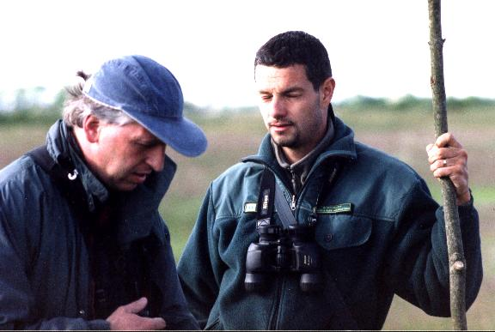
Martin and Zsolt in the field at Borsós (Photo: Oskars Keiss)

16.05.2004, Borsós, place 1b, c. 40 ha

5 male AW caught, ringed and sampled.

Habitat description

Relatively dense, very homogeneous vegetation stand, sedges (mainly Carex melanostachion) of 60-80 cm height and grasses (mainly Alopecurus pratensis) of 120-140 cm height are predominating. From some distance it looks like a pure Alopecurus stand. The soil is moist to wet (alkaline, salty), water table maximum 5 cm above ground (in old ditches and tractor trails up to 30 cm). In summer, this habitats dry out completely. No mosses occur, underground is very stable, with small to medium inhomogeneous tussocks. Some small patches of Glyceria fluitans.

Plan species ranked by coverage (Arcady):

Dominant:  Carex melanostachion  Alopecurus pratensis  Carex riparia  Elytrigia repens  Subdominant:  Cicuta virosa  Rorippa cf. austriaca  Cirsium palustre  Cirsium oleraceum  Rumex hydrolapathum  Lysimachia nummularia  Galium uliginosum | Cirsium pannonicum  Lycopus europaeus  Eleocharis palustre  Galium palustre  Carex vulpina  Schoenoplectus lacustris  Typha cf. angustifolia  Lytrum virgatum  Polygonum hydropiper  Poa palustris  Poa pratensis  Juncus conglomerates  Glyceria fluitans (ditches)

Bird species observed within the AW habitat (40 ha):

Montagu’s Harrier | Circus pygargus | 1 m foraging
Quail | Coturnix coturnix | several calling outside the study plot
Corncrake | Crex crex | 3 sing. m
Snipe | Gallinago gallinago | 1 displaying
Yellow Wagtail | Motacilla flava | c. 20 bp
Grashopper Warbler | Locustella naevia | 4-5 sing. m
Aquatic Warbler | Acrocephalus paludicola | 5-7 sing. m, 1 female with eggs in ovary
Sedge Warbler | Acrocephalus schoenobaenus | 15-20 singing and alarming
Reed Bunting | Emberiza schoeniclus | c. 20 bp

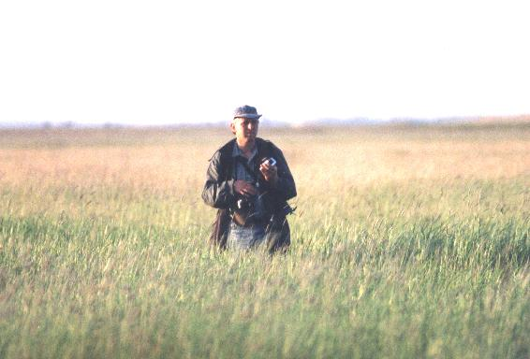
Martin during field work at Borsós, Hortobágy (Photo: Oskars Keiss)
17.05.2004, Borsós, place 1c, >= 100 ha

2 male AW caught, ringed and sampled.

Habitat description

Similar to place 1b, but vegetation higher and with some gaps (water, mud). Water table distinctly higher (5-15 cm above surface, in ditches up to 60 cm). In an AW territory only (!) Alopecurus pratensis and Elytrigia repens.
Density of AW is extremely low (only 2 singing males within > 100 ha);
conclusion: vegetation is too high and habitat is too wet compared to place 1a and 1b.

Plant species (Arcady):

Halophytes:  Carex melanostachion  Cardamine flexuosa  Stellaria uliginosa  Eleocharis uniglumis  Other plant species:  Alopecurus pratensis  Carex vulpina  Carex riparia  Ranunculus polyphyllos  Ranunculus repens  Poa palustris  Poa pratensis  Elytrigia repens  Utricularia australis  Typha latifoglia  Typha angustifolia | Glyceria maxima  Glyceria plicata  Glyceria fluitans  Calamagrostis neglecta  Eleocharis palustre  Cirsium palustre  Cicuta virosa  Rumex hydrolapathum  Lysimachia nummularia  Galium uliginosum  Lycopus europaeus  Rorippa austriaca  Schoenoplectus lacustris  Lytrum salicaria  Polygonum hydrolapathum  Juncus artratus  Phalaris arundinacea  Lemna minor

Bird species observed within the AW habitat (>= 100 ha):

Corncrake | Crex crex | 5 sing. m, 1 nest with clutch
Spotted Crake | Porzana prozana | 1 sing. m, 1 nest with clutch
Snipe | Gallinago gallinago | >= 2 displaying
Yellow Wagtail | Motacilla flava | many, 80-100 bp in total
Grashopper Warbler | Locustella naevia | 5-10 sing. m
Savi’s Warbler | Locustella luscinioides | 2 sing. m
Aquatic Warbler | Acrocephalus paludicola | 2 sing. m only
Sedge Warbler | Acrocephalus schoenobaenus | very common, >= 12 bp/10 ha, more than 120 bp in total; 3 nests with eggs
Reed Bunting | Emberiza schoeniclus | very common, > 100 bp

AWCT Discussion Group, 17th May

Topics: 1. AW in the Pomeranian region
2. How different are the Hungarian habitats?
3. Ukrainian flyway project
4. New research results from Belarus
5. AW on migration and in Africa
6. Any other questions

1. AW in the Pomeranian region

Victor summarised the planned Polish-German EU-LIFE Project.

Martin outlined the planned study of Franziska Tanneberger (phD) on the AW habitats in the lower Odra region (analysis of key habitat factors).

Main problems at the Polish side are: reed succession on the one hand, reed cutting for thatching on the other, and decline of water table.

Fernando: We tried four different management methods at La Nava: mowing, grazing, burning and …(?).

Jarek: We have to find sustainable management methods. Points to a UK study on reed use.

Janusz: Question is, how Franziskas results can be transferred into practice.
Nesting places of females are more important than song posts of males => try to measure as many nesting places as possible.

Alexander: Experimental approach with different water tables could be worthwhile in order to detect main vegetation changes. Idea: check aero photographs from the past decades to detect general vegetation changes.

Zsolt has contact addresses from spider specialists who studied habitat and vegetation structures.

Zsolt: Are genetic differences reflected in song differences? Have sub-populations different songs?

Alexander: Grzegorz’ recording from the Swina delta seems to be distinctly different to Belarus!
(P.S.: Martin actually felt the same with recordings from AW in the lower Odra valley!!)

Conclusion:
- Zsolt writes an outline of project and methods to collect and analyse recordings from different sub-populations (10-15 birds each). He would analyse this differences. Sample sites: Pomerania, Biebrza, Chelm marshes, Lithuania, N-Belarus, SW-Belarus, NW-Ukraine, central Ukraine, Hungary.

2. How different are the Hungarian habitats?

Description of habitats see above and below.
People agreed, that habitats are not that different as expected, but have an alkaline and salty (not peaty) soil.

Zsolt: We had also habitats of pure Juncus conglomerates tussocks (see published paper)!

Alexander: Hungarian habitats are very similar to some habitats in the Styr and Stochid valleys.

Zsolt: Hortobágy was Tisza floodplain up to the second half of the 19th century (former glacial spillways); whole Hortobágy is a salty alkaline former floodplain of the Tisza and it’s northern tributaries; the continuously moving Tisza river and tributaries formed this whole huge alluvial areas (soils like this have formed c. 26,000 years ago).

Some conclusions of the following discussion:
- Similar areas could occur in central/southern Ukraine, Carex melanostachion also occurs there (Arcady).
- Anatoly should check this with botanists (Tatyana Adrienko?) for Ukraine!
- For Kazakhstan this could be also possible, but more unlikely.
- In W-Siberia could occur similar habitats; Arcady to correspond with Elena Lapshina to check this; if there are similar areas in the W-Siberian forest steppe, it could be worthwhile to search there again.

Fernando: we could carry out stable isotope studies in the feathers of juvenile birds to detect unknown breeding areas.

Result of discussion:
We should not follow this proposal for the following reasons:
- Very big effort; we would have to catch several hundred birds of Aquatic (and probably Sedge) Warblers in all currently known breeding sites to get the necessary reference values.
- If we catch juvenile birds on passage (Benelux, France, Spain), we would probably find no differentiation in longitude (what we need), only in latitude.

3. Ukrainian flyway project

Anatoly: One part of the project is, according to the Bonn Convention on Migratory Species (CMS), to investigate a possible Balkan flyway. There is information from Bulgaria about captures of several Tens of AW alt Lake Atamasiova, but 20 years ago. But:
- Most birds have recently been ringed in central Ukraine (Uday/Supoy), but no recovery;
- Only 20 birds have been ringed in NW-Ukraine, and we have already one recovery from the Netherlands.
The hypothesis is, that central-Ukrainian population takes the Balkan flyway. On the other hand: If there exists a Balkan flyway, most of the birds probably use the Danube delta as resting site. Anatoly caught birds in the Ukrainian Danube delta with huge concentrations of Sedge Warblers, but there was not any recovery of AW. He thus thinks, that the concentration of AW must be very low, but it could make sense to use tape lures for catching AW! According to experiences in the Netherlands, Belgium, France and Spain this could be successful!
Distance from central-Ukraine to Danube delta is approximately one night of flight.

Zsolt: If recent ringing stations do not start ringing before 1st of August, they may miss most of the AW (!!); the first step, therefore, would be to collect information, in which periods the ringing stations are (or have been) active.

Conclusion of discussion:
- To catch AW in the Danube delta in July and August.
- We need ringing stations in Bulgaria (Lake Atamasiova) and in the Danube delta which start early with ringing (July) and use tape lures (Fernando suggests also to use colour rings).
- Anatoly will visit the Danube delta this year and will try to make contact; Zsolt also has contact into the Romanian delta; they should try to clearify the situation.

4. New research results from Belarus (Alexander)

Nest locations:
- Not all nests are on the ground.
- There are nests up to 40-50 cm high in old vegetation on a ‘platform’; breeding success is not very high, because many nests or chicks fall down.
- After fire, some nests are in holes (cavities) in big tussocks, in some occasions many nests!

Number of broods:
- Normally: 1st brood in May, 2nd brood in July;
- In 2003: In Zvanets nearly no early broods at all; continuous increase of number of breeding females from late May until 20th July; latest chicks fledged on 20th August!
- The same occurred in number of males: In late May 70 males/km², in July 137 males/km².
- Sasha believes, that the birds are present all the time, but do not sing or breed; birds are there (they have sightings), sometimes singing shortly, but not actively.

Change of sites:
- AW change sites due to special conditions during breeding season due to flooding and fires. Example Yaselda/Peschanka: 1st July, 2nd broods started, then came a flooding, all birds disappeared; at the same time at Kokoritsa (S Sporova Lake, c. 20 km downstream), which was not flooded, a big increase in number occurred!
- Yaselda: After three dry years the density dropped from 135 to 50 sing. males/km²!

Feeding, diet:
- C. 700 samples from nestlings using ligatures (at the beginning three losses due to inexperienced co-workers); same mire, same method, different species: Sedge Warbler, Reed Bunting, Meadow Pipit. In parallel, study on insects was done (Malaise trap, catching net etc.).
- Result: AW collect everything which lives there, very different according to daytime; e.g. in the morning mosquitoes, Diptera, at noon dragonflies.
- Diet changes completely during the season according to insect supply. Also many spiders are taken.
- Main food: Tabernidae, Lepidoptera (caterpillars), grasshoppers.
- Difference between Sedge and Aquatic Warbler: for two mires there is no difference! But analysis of Zvanets data is not finished yet.

- Karl: Comparison of size/shape of prey, but also of amount of food per feeding is of interest; the hypothesis is, that uniparental care is possible due to larger prey or bigger portions.
- Bernd Leisler & Karl formerly assumed, that AW would bring the largest prey, and uniparental care is possible due to larger prey; but this might be wrong!

Breeding success:
- Breeding success changes very strongly between years (Mayfield method): 40-50 % in good years, in other years only 3 % (!!), due to Shrew Sorex spec. predation; three Sorex species occur.
- Sorex predation is only that high in Dikoe (peak every four years).
- In Yaselda, main problems are floods or droughts.
- In Zvanets, the situation is more stable (tussocks), 40 % success (Mayfield), main predator is Arvicola terrestris.

- Conclusion: Each mire has its own features/characteristics and own functioning; all results are valid only for the respective mire (!!) and vary strongly from year to year, during the breeding season and during daytime (diet).

Following discussion:

Karl: Is it possible to establish a reproductive monitoring?

Alexander: We do this for our monitoring plots every year (we calculate productivity).

- Hypothesis: AW can adapt more strongly, quickly and efficiently to changing conditions in comparison to other species => this enables uniparental care. Fen mires are very unstable ecosystems. AW are very well adapted to these conditions.
- ‘Benefit of mobility’ is too short: should be ‘benefit of flexibility’!

Janusz: This is similar to Corncrake, and also Skirtland Warbler and Sharp-tailed Sparrow in USA.

Alexander: Sex ratio males : females is in total 10 : 4 (first brood), but this includes only females with nests, so sex ratio might be more equal; not all females of the 1st brood do 2nd broods and vice versa.

Benedikt: Sex ratio of nestlings (DNA analysis) was 1 : 1, the same in Belgium and La Nava (Spain).

Alexander: In Polessye overall stable population during the past 10 years; single sites show strong fluctuations, the whole region distinct fluctuations, but altogether stable or slight increase.

Jarek: That means, that proper management (e.g. excluding negative events like fire etc.) could increase the population.

Alexander: Major negative factor is the increase of bushes/shrubs (increase from 10 to 20 % since 40 years).

Karl: Why do local people burn?

Alexander: Because they still use the areas sometimes for hay cutting; in the year after fire, the old vegetation is removed, thus there is more light, grasses are growing very good and quick, and more productive. Fire removes the reed, but then reed comes even stronger. Bushes (willows) can be destroyed completely.

Jarek: It is a problem, that use of fire is not allowed in Poland.

Discussion followed on possibilities and problems to use controlled fire in Poland, Belarus and Hungary.

Some general conclusions:

- AW mating system has the big advantage to ensure this mobility and flexibility!
- In contrast to other species, the AW is most ‘specialised’ to fens.
- Today’s ‘specialisation’ was not ‘specialised’ in former times, because huge areas were covered by fen mires; it was or is the same degree of specialisation like ‘deciduous forests’ or ‘raised bog’.

5. AW on migration and in Africa

Referring to a possible AWCT expedition to Africa:
- We should wait for Debbie’s full results.
- We will need Africa-experienced people and very experienced ringers.

Fernando:
Hypothesis: Long non-stop flights may be not possible for AW; AW may be dependent on many coastal wetlands along the African coasts as resting sites – which are actually threatened by agricultural intensification.
Background: Analysis of data on wing length and shape, as well as fat load and muscles (Kaiser scale); on the basis of this data an extrapolation of possible flight distance is possible; result: maximum non-stop flight of AW is likely 400-500 km only! AW fat score is very different: sometimes 1-2, sometimes 8 (up to 16 g). Thus, Fernando does not believe that they jump over the Sahara (2000 km).

Fernando goes to Mali and Burkina Faso in November/December (Raining season!) together with an Spanish expedition; there is the huge Niger delta (600 km²) with large areas of marshy grassland habitats; very hard access to the area, but there is a transect road which could be used for testing. He will use tape lures of AW when catching and focussing on suitable habitat patches.

Alexander: All changes in breeding populations can be explained by changes in breeding habitats. There is not any evidence or even indication, that changes in passage or wintering sites do have an important effect on the population dynamics.

Martin: In the past, habitat loss of breeding habitats obviously was at least quicker than changes in resting and wintering habitats – but this may change. Up to now, the breeding habitats were the bottle neck; but in future, resting and wintering habitats may become the (new) bottle neck.

Main conclusions:
- Waiting urgently for Debbie’s results in order to identify the target region in Africa for a targeted AWCT winter expedition (earliest in 2005/2006) to search for wintering sites.
- Noticing, that Fernando goes to Mali/Mauritania in Nov./Dec.- we are very curious what he will find.
- Being aware of Fernando’s hypothesis, that AW may be unable to perform longer non-stop flights and thus might be dependent on a continuous row of coastal wetlands in Africa, which actually are in danger. Protection of this coastal wetlands is of prime importance, not ‘only’ in terms to protect AW.

New idea:
The Pomeranian population could winter in Morocco and/or Tunisia (because it winters distinctly north from the core population); unlikely in Spain, because ringing activity there is very high.

6. Any other questions

Egg shell structure
Oskars analysed the potential AW eggs found 80 years ago in Latvia. He examined with the microscope the pattern of the egg shell structure. It was more similar to Karl’s AW egg but different to Sedge Warbler eggs. Question: is this method valid?
- All AW members are asked to send egg shells of AW and Sedge Warbler eggs to Oskars for further analysis!

AW conference in Palencia
Fernando invites us for an AW conference in La Nava/Palencia (in course of the EU-LIFE Project), preferably in mid-August 2005 (peak of AW captures).

Summarising description of the Aquatic Warbler core habitats in the Hortobágy

After seeing also the AW key breeding areas at Nagyvan.

A more or less salty steppe landscape in the former floodplains of several tributaries of the Tisza river. Parts, especially on the edge of the area, are covered by a sparse, low and patchy soda steppe vegetation with large, shallow depressions (up to several km square in size), which are periodically covered by water (actually there occurs an artificial flooding with river water in late winter/early spring to favour the Aquatic Warbler).

The AW habitats occur in these large shallow depressions and are dominated in the upper vegetation layer (up to 1 m height) by Alopecurus pratensis (looks like a monoculture from some distance). At ditches and ponds there are some islands of higher vegetation, especially formed by Schoenoplectus tabernaemontani, Schoenoplectus lacustris, Typha latifolia and angustifolia, some patches also with Phragmites australis.

This apparently monotonous Alopecurus fields have a second, approx. knee-high (50-60 cm) layer, were Carex melanostachion is dominant. Following Arcady Skuratovitch, Carex melanostachion is a typical forest steppe species which is missing in Central Europe. He regards this sedge as a very good indicator species for this vegetation type.

Further plant species have been:

Carex vulpina  Carex riparia (small patches only)  Eleocharis uniglumis  Eleocharis palustre  Cardamine flexuosa  Stellaria uliginosa  Ranunculus polyphyllos  Ranunculus repens  Poa palustris  Poa pratensis  Elytrigia repens  Utricularia australis  Glyceria maxima | Glyceria plicata  Glyceria fluitans  Calamagrostis neglecta  Cicuta virosa  Cirsium palustre  Rumex hydrolapathum  Galium uliginosum  Lycopus europaeus  Rorippa austriaca  Lytrum salicaria  Polygonum hydrolapathum  Juncus artratus  Bidens tripartita

The areas are not or only occasionally used by agriculture (cattle grazing).

During the breeding season in mid-May (in W-Siberia mid-June) there was nearly no water on the ground, but earlier in the year the area was covered by shallow water. - There are no or only very few willow bushes.

AW ringing list Hortobagy National Park 2004 – Borsós near Hortobagy village

Please notice:

Unfortunately, Hungarian rings were not available in the field. This has only been realised as the catching work had already started. Thus we took the ad-hoc decision in the field to use German rings (Vogelwarte Hiddensee), because catching and feather sampling has only sense in combination with marking the birds.

Date | Ring Number | age | sex | weight | wing | Teilfeder-länge | Tar-sus | Cul-men | NaLo  Spi | Comments
15.5.04 | HI - ZB 15 240 | ad. | F | 12.7 | 64.0 | 48.0 |  |  |  | with eggs
15.5.04 | HI - ZB 15 241 | ad. | M | 11.5 | 63.0 | 47.5
15.5.04 | HI - ZB 15 242 | ad. | M | 12.7 | 63.0 | 46.5
15.5.04 | HI - ZB 15 243 | ad. | M | 11.6 | 64.5 | 48.0
16.5.04 | HI - ZB 15 244 | ad. | M | 14.7 | 62.0 | 45.3
16.5.04 | HI - ZB 15 245 | ad. | M | 12.6 | 64.0 | 48.0
16.5.04 | HI - ZB 15 246 | ad. | M | 13.5 | 64.0 | 47.5
16.5.04 | HI - ZB 15 247 | ad. | M | 12.0 | 64.0 | 46.5
16.5.04 | HI - ZB 15 248 | ad. | M | 11.5 | 64.0 | 47.0
17.5.04 | HI - ZB 15 249 | ad. | M | 12.3 | 65.0 | 47.0 | 20.2 | 14.1 | 7.2 | fat score 2
17.5.04 | HI - ZB 15 250 | ad. | M | 12.8 | 63.5 | - | - | 14.5 | 6.6 | fat score 2

Full AWCT birding list Hortobágy National Park, 15-20th of May 2004

- Acanthis cannabina  - Acrocephalus arundinacea  - Acrocephalus paludicola  - Acrocephalus palustris  - Acrocephalus schoenobaenus  - Alauda arvensis  - Anas clypeata  - Anas platyrhynchos  - Anas querquedula  - Anas strepera  - Anser anser  - Apus apus  - Aquila pomarina  - Ardea cinerea  - Ardea purpurea  - Ardeola ralloides  - Aythya farina  - Aythya fuligula  - Aythya nyroca  - Botaurus stellaris  - Buteo buteo  - Buteo rufinus  - Calidris alpina  - Calidris ferruginea  - Calidris minuta  - Calidris temmincki  - Caprimulgus europaeus  - Carduelis carduelis  - Carduelis cloris  - Ciconia ciconia  - Circus aeroginosus  - Charadrius dubius  - Charadrius hiaticula  - Chlidonias hybridus  - Chlidonias niger  - Circus pygargus  - Columba palumbus  - Coracias garrulus  - Corvus cornix  - Corvus frugilegus | - Corvus monedula  - Coturnix coturnix  - Crex crex  - Cuculus canorus  - Delichon urbica  - Egretta alba  - Egretta garzetta  - Emberiza calandra  - Emberiza citrinella  - Emberiza schoeniclus  - Falco cherrug  - Falco tinnunculus  - Falco vespertinus  - Ficedula hypoleuca  - Fringilla coelebs  - Galerida cristata  - Gallinago gallinago  - Gallinula chloropus  - Grus grus  - Haliaeetus albicilla  - Himatopus himatopus  - Hippolais icterina  - Hirundo rustica  - Ixobrychus minutus  - Lanius collirio  - Lanius minor  - Larus cachinnans  - Larus melanocephalus  - Larus minutus  - Larus ridibundus  - Leucorrhinia platarola  - Limicola falcinellus  - Limosa lapponica  - Limosa limosa  - Locustella luscinioides  - Locustella naevia  - Luscinia megarhynchos  - Luscinia svecica  - Merops apiaster  - Motacilla alba | - Motacilla flava  - Muscicapa striata  - Numenius arquata  - Nyctocorax nycticorax  - Oenanthe oenanthe  - Oriolus oriolus  - Otis tarda  - Panurus biarmicus  - Passer domesticus  - Passer montanus  - Phalacrocorax carbo  - Phalacrocorax pygmeus  - Philomachus pugnax  - Phoenicurus ochruros  - Pluvialis squartarola  - Podiceps cristatus  - Podiceps nigricollis  - Porzana porzana  - Rallus aquaticus  - Recurvirostra avosetta  - Remiz pendulinus  - Riparia riparia  - Saxicola rubetra  - Saxicola torquata  - Serinus serinus  - Sterna hirundo  - Streptopelia decaocto  - Streptopelia turtur  - Sturnus vulgaris  - Tachybaptus ruficollis  - Tringa totanus  - Troglodytes troglodytes  - Turdus merula  - Tyto alba  - Sylvia atricapilla  - Sylvia communis  - Sylvia curruca  - Sylvia nisoria  - Upupa epops  - Vanellus vanellus

